**CSE523: Machine Learning**

**Project Progress Report**

**Breast Cancer Detection**

**Group:  The Curators**

| **Name** | **Roll number** |
| --- | --- |
| **Harsh Patel** | **AU1940114** |
| **Kavan Desai** | **AU1940126** |
| **Sarthak Bharad** | **AU1940176** |

1. **Tasks Performed in the week.**

* We performed KNN classification on the data set

1. **Outcomes of the tasks performed.**

* Misclassification rate

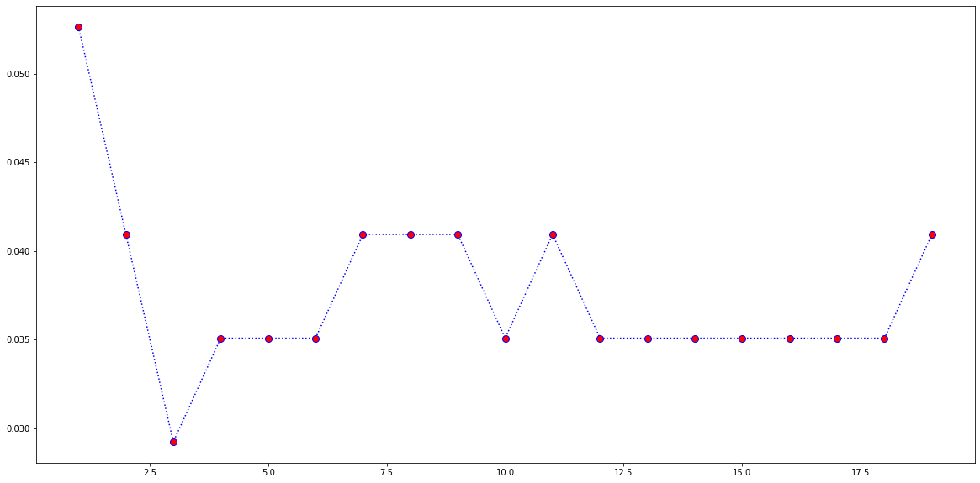

* Found K=3 is the best suitable value of K for the KNN classification
* We found the accuracy 0.9707602339181286 using KNN classification with k value 3.
* [Google Collab link](https://colab.research.google.com/drive/12XEtj5SYwWTyFbtKGeiI4bBoaPnCyNAe#scrollTo=d1cvkweJ1bbE)

1. **Tasks to be performed in the upcoming week.**

* We will try to explore more classification methods which are suitable for breast cancer detection.